**EXP NO : 10**

**DATE : 11-02-2023**

**INSTALL A C COMPILER IN THE VIRTUAL MACHINE CREATED USING VIRTUAL BOX AND EXECUTE SIMPLE PROGRAMS**

**AIM :**

To install C compiler in the Virtual Machine.

**PROCEDURE :**

1.Start the Virtual Machine.

2.Open the Terminal.

3.Give the Command “Sudo apt install gcc”.

4.Connect to the internet.

5.It will automatically download the C compiler.

6.To test it type a program in Text Editor and save it with filename.c extension

7.then run it with command “cc filename.c”.

8.to get the output type “./a.out”.

9.Now you can see the C program output in the Terminal.

**OUTPUTS**

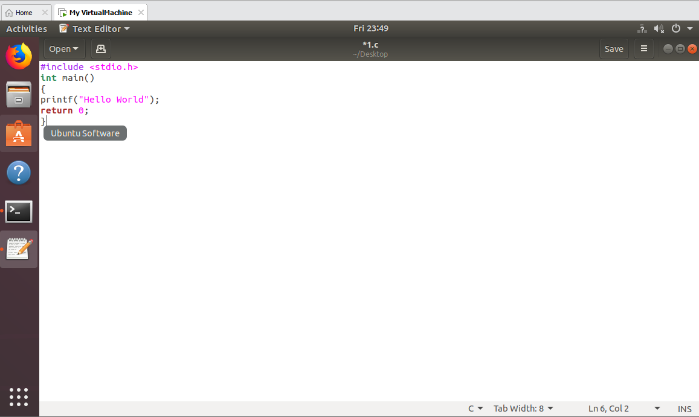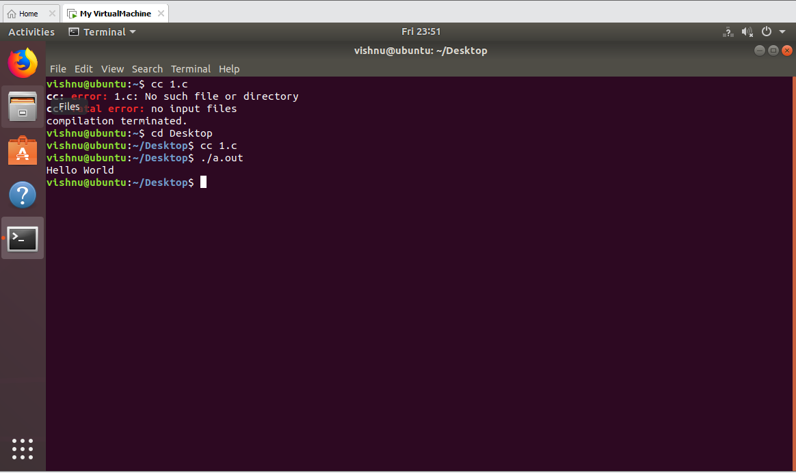

**RESULT:**

Hence the C compiler in the Virtual Machine is installed.